Performance Analysis of Message Passing vs. Shared Memory Concurrency Models in Go
Jatin
Associate Software Development Engineer (Intern)
OYO
Gurugram, India
Jatinsihag16@gmail.com
Vinit
Associate Software Development Engineer (Intern)
OYO
Gurugram, India
Vinitv275@gmail.com

Abstract—Making the most of your multicore processors is essential to developing scalable backend systems. One of two methods is usually used by Go developers to manage concurrency: shared memory with sync.Passing messages over channels is known as mutex. Engineering teams frequently question whether strategy works better in real-world microservices, despite the Go community's strong support for Channels ("share memory by communicating"). To provide developers with precise instructions on when to utilize each model, we benchmarked the true performance overhead of each in this study. To quantify latency and throughput under both low and high-stress parallel loads, we conducted a number of tests on an Apple M1 (ARM64) processor. We discovered that sync works for straightforward, sequential updates.Compared to 137.3 ns/op, Mutex is around ten times faster (13.84 ns/op). However, because lock contention significantly slowed down the Mutex, that performance difference completely disappeared under high parallel contention (78.63 ns/op for Mutex vs. 76.17 ns/op for Channels). In the end, Channels manage chaotic parallel traffic exceptionally effectively, despite having a severe performance cost for basic operations. Channels become very competitive when coordinating intricate, highly parallel activities, while mutexes are still the best option for simple atomic counters.
Keywords: ARM64, Go, Concurrency, Channels, Mutex, and Performance Analysis

I. INTRODUCTION
Nowadays, creating fast backend systems requires figuring out how to maximize the potential of multicore computers. The way you manage concurrency while scaling up microservices can either make your system extremely fast or totally bottleneck it. Because of its goroutines, which are lightweight threads that make managing concurrency relatively simple, Go (Golang) has emerged as the preferred language for cloud programming.
However, developers must decide between two very different methods when those goroutines need to share data: the conventional shared memory solution that uses sync.mutex locks or the channel-based message-passing method.
Go writers are familiar with the well-known saying, "Do not communicate by sharing memory; instead, share memory by communicating." Although it is excellent guidance for developing clear, thread-safe code, it presents a practical challenge for engineering teams. We frequently question whether selecting the security of channels is covertly slowing down our most important, busy code pathways.
We choose to use actual data to test that hypothesis in this research. We compared the raw latency and throughput of Mutexes with Channels using rigorous benchmarks on an Apple M1 (ARM64) chip, paying particular attention to what occurs when the system is subjected to significant parallel load.

II. LITERATURE REVIEW
The majority of the research that has been done on Go concurrency is primarily concerned with identifying flaws and making sure that the code is accurate.
For example, recent research on large open-source Go projects reveals that developers still frequently use traditional shared memory (Mutexes), despite the Go community's strong encouragement to use message forwarding.While channels can make your architecture appear cleaner, both approaches can easily result in deadlocks or blocking issues if you're not careful, according to other study on automated bug-catching.
But we found a significant gap in all of this research. While safety and bug rates have received a lot of attention from the academic community, raw hardware execution costs have received very little attention. CPU cycles are mostly ignored in the literature. By offering precise, tangible data on contemporary technology, such as the Apple Silicon (M1) chip, we aimed to close that gap and provide developers with factual data to inform their design choices.

III. METHODOLOGY
Using Go's built-in testing package, we created a custom benchmark suite to ensure our test was accurate and fair. We wanted to examine how these models performed on cutting-edge, highly efficient hardware, so we conducted all of our experiments on an Apple M1 (ARM64) processor.
We choose to assess two particular situations:
A. Low Contention Sequential Execution Initially, we aimed to separate each model's baseline cost from any background noise. With no other goroutines vying for it, we executed a single loop that updated a state one step at a time.
- Mutex Implementation: We used a basic integer increment wrapped safely in mu.Lock() and mu.Unlock().
- Channel Implementation: We set up a background monitor goroutine listening on an unbuffered channel, and sent empty structs (struct{}{}) to signal the update.
B. High Contention Parallel Execution Our next goal was to replicate a crowded, heavy microservice. We employed To make thousands of goroutines attempt to change the same state at the same time, use b.RunParallel().
- Mutex Implementation: This meant thousands of goroutines aggressively fighting for the exact same lock, which allowed us to observe forced lock contention.
- Channel Implementation: We used a buffered channel acting as a thread-safe queue, with one monitor goroutine smoothly processing the massive flood of parallel requests.
For both tests, we measured the performance based on the time it took per operation in nanoseconds (ns/op).

IV. RESULTS AND PERFORMANCE EVALUATION
Our benchmark tests produced extremely clear findings, highlighting the strengths and weaknesses of each model.
A. Sequential Baseline Overhead The Mutex completely ruined the Channel at breakneck speed when there was no opposition to the state.
- Mutex: 13.84 ns/op
- Channels: 137.30 ns/op
The Mutex was about ten times quicker. This makes sense when you examine the inner workings of a Go Channel, which is a sophisticated data structure with additional logic for queue management and memory allocation in addition to its own internal Mutex. Setting up a channel is basically needless overhead for a straightforward, one-at-a-time update.
B. Strong Conflict (Parallel) However, the situation drastically changed when we applied a high parallel load to the system.
- Mutex: 78.63 ns/op
- Channels: 76.17 ns/op
The Channel stabilized and even significantly outpaced the Mutex under extreme stress, but the Mutex drastically slowed down. Lock conflict was the cause of this. Thousands of goroutines competed for CPU time in the Mutex test, merely spinning and awaiting the lock to open. In contrast, the Channel behaved like a cunning traffic cop. It proved to be far more effective for the ARM64 chip by putting blocked goroutines to sleep and waking them only when it was their turn, rather than allowing them to battle.
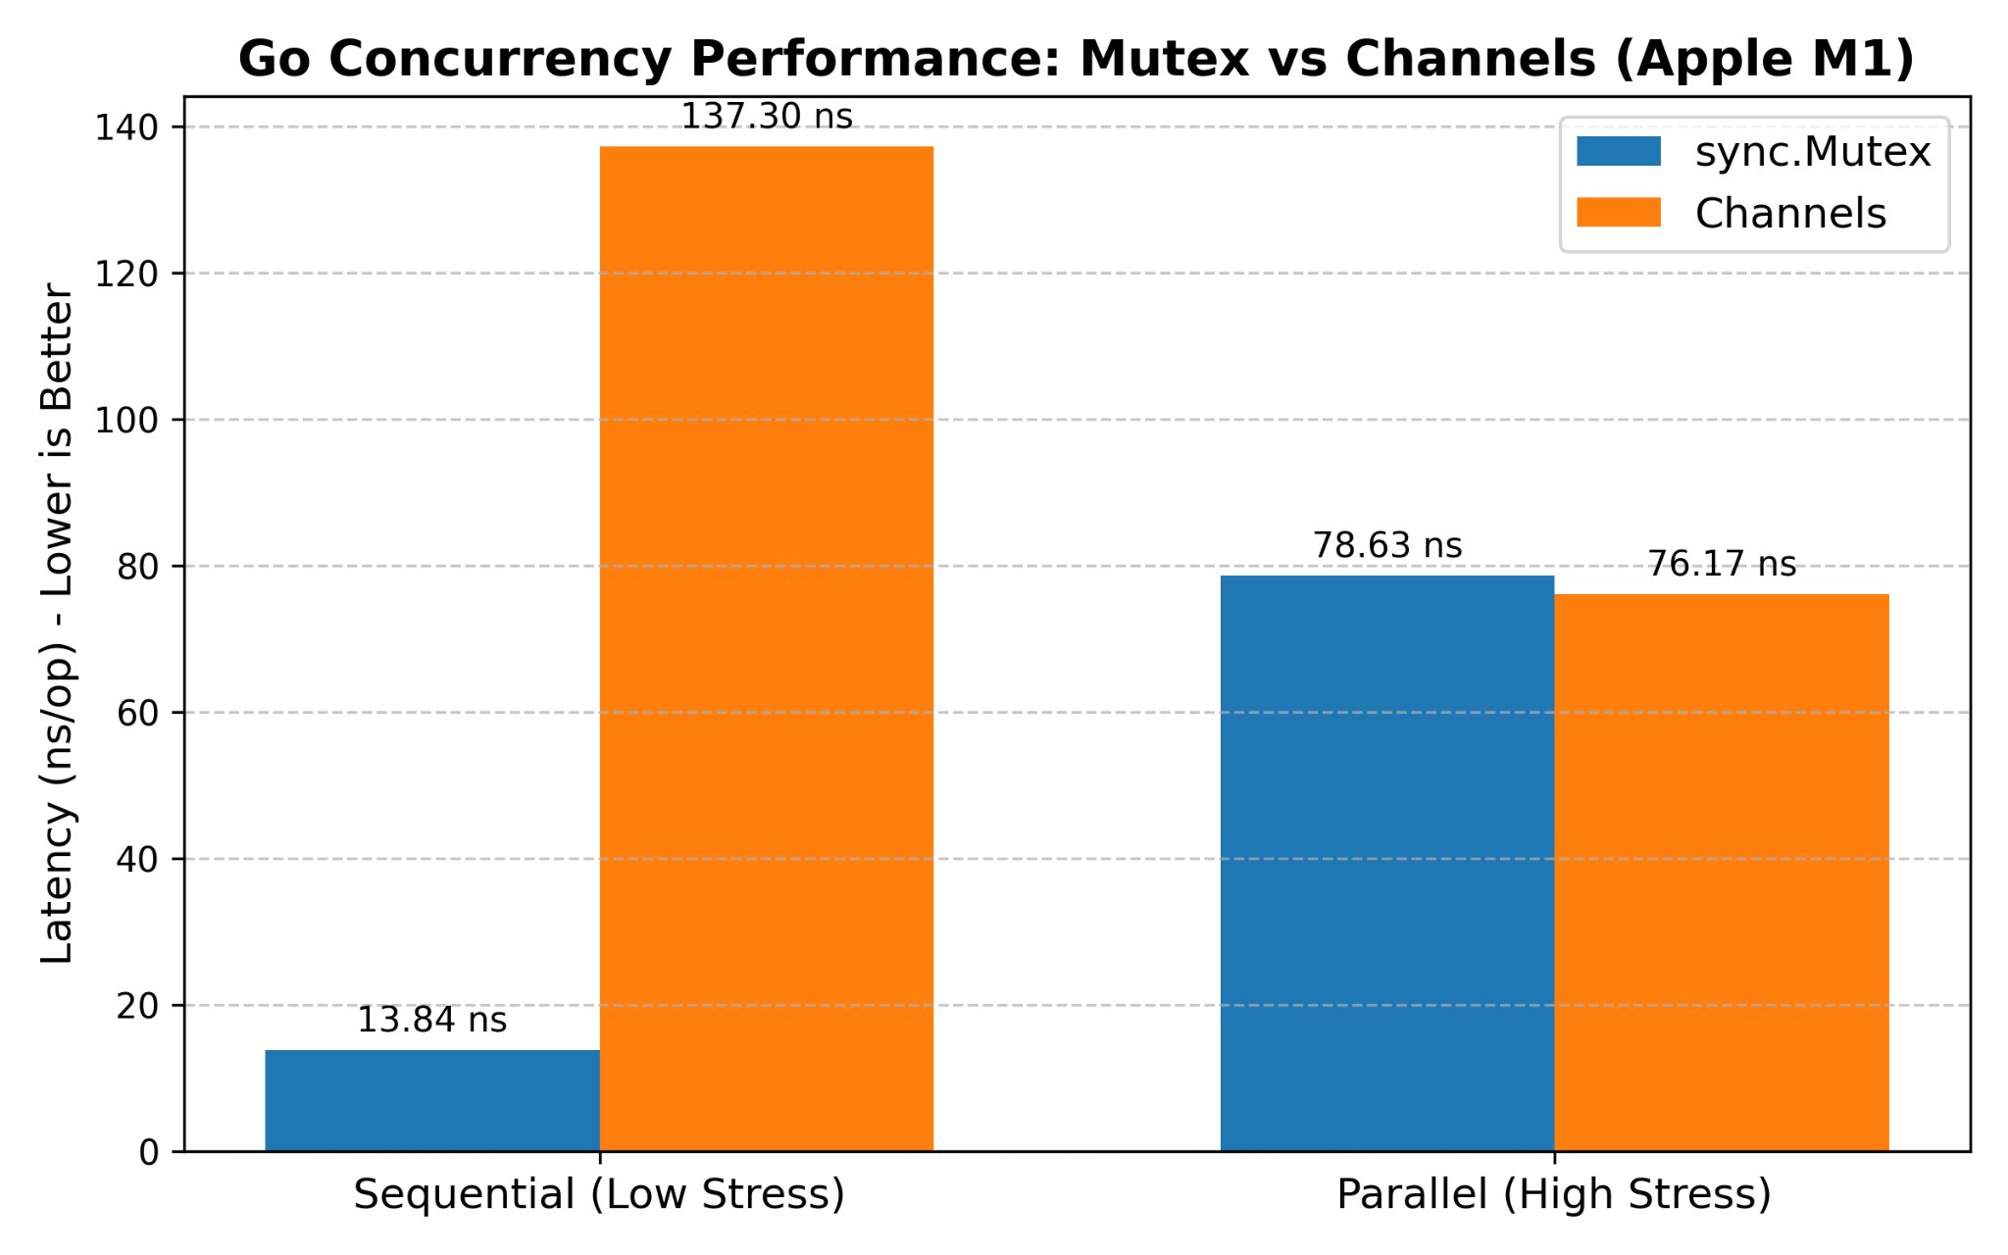

V. DISCUSSION
What does this really mean for engineers who write Go applications, then?
Sync should be used when handling small, atomic state updates, like caching a simple variable or increasing a simple counter.Mutex. The lock is only maintained in this instance for a few tens of nanoseconds. Really, no one is vying for it. You get unparalleled speed.
However, you should use Channels if you need to manage intricate worker scenarios or data processing pipelines. Indeed, their overhead is little more than Mutex's. They do, however, perform admirably in situations with high parallelism. They impose good design principles on your code and stop your CPU from spinning in vain.

VI. CONCLUSION
Ultimately, we wanted to test Go's message passing and shared memory (Mutex) on actual hardware. And we were able to demonstrate that while syncing by running these benchmarks on an Apple M1 processor.Channels are incredibly stable, Mutex is far better for straightforward, uncontested situations, and channels even outperform Mutex under parallel load.
The primary lesson to be learned from this is that, although Go's concurrency maxim should be adhered to, performance should not be determined by it. The finest systems will combine the usage of channels to properly handle the enormous flow of data in an application with Mutex for maximum performance in a localized state.

REFERENCES
[1] R. Pike, "Go Proverbs," go-proverbs.github.io, 2015. [Online]. Available: https://go-proverbs.github.io/ [2] K. A. Cox-Buday, Concurrency in Go: Tools and Techniques for O'Reilly Media, 2017. Developers. [3] "An Empirical Study of Messaging Passing Concurrency in Go Projects," T. Tu, X. Liu, L. Song, and Y. Zhang, IEEE 26th International Conference on Software Analysis, Evolution and Reengineering (SANER), Hangzhou, China, 2019. [4] "GoAT: Automated Concurrency Analysis and Debugging Tool for Go," Z. Yuan et al., IEEE International Symposium on Workload Characterization (IISWC), Storrs, CT, USA, 2021. [5] "Communicating Sequential Processes," C. A. R. Hoare, Communications of the ACM, vol. 21, no. 8, pp. 666–677, 1978.

